
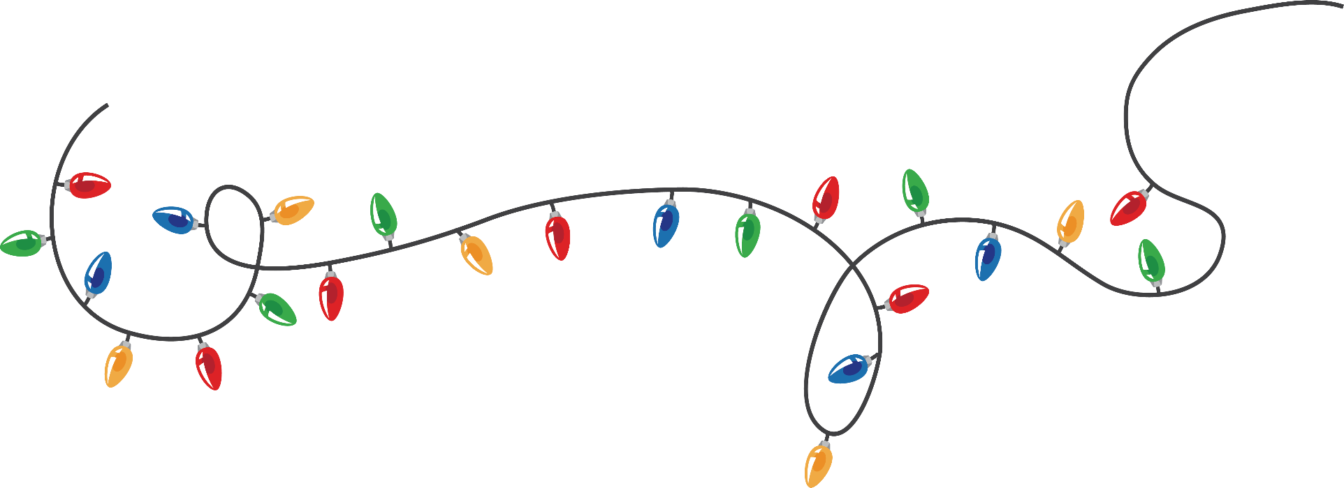

Merry Christmas

24th December 20___
Lorem ipsum dolor sit a met Consectetur adipiscing elit Vivamus vitea luctus leo vitae Dignissim quam Sed placerat neque in ele entum euismod risus sed urna Purus, volute Pat quis varius id fragile non-urna.

Drinks & Music | Free Entry | Doors Open at 10PM

Entry $ 25 & Free for Ladies / Red Dress Code
For Reservation: +123-456-7890 / Free Cocktails

Your Club Name
592 Escalante Court, Oakland
rsvp’s 555 - 289696

