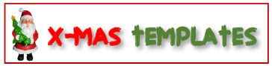



Merry Christmas

Valid throughout the holidays!
NO. 12345678
To: ________________

From: ______________
(You can add more details about your message in this space.)

A discount of $40 on purchasing gift item at our (Name & Location)
Amount: _____________ To: ________________
Merry Christmas
Gift Certificate
Merry Christmas

Valid throughout the holidays!
NO. 12345678
To: ________________

From: ______________
(You can add more details about your message in this space.)

A discount of $40 on purchasing gift item at our (Name & Location)
Amount: _____________ To: ________________
Merry Christmas
Gift Certificate
Merry Christmas

Valid throughout the holidays!
NO. 12345678
To: ________________

From: ______________
(You can add more details about your message in this space.)

A discount of $40 on purchasing gift item at our (Name & Location)
Amount: _____________ To: ________________
Merry Christmas
Gift Certificate

