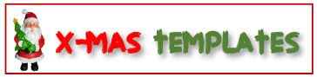



A SPECIAL GIFT FOR YOU!
Valid throughout the holidays!
NO. 12345678
(You can add more details about your message in this space.)

A discount of $40 on purchasing gift item at our (Name & Location)
Merry Christmas Gift Certificate
To
From
Amount

