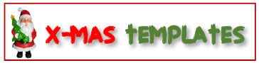
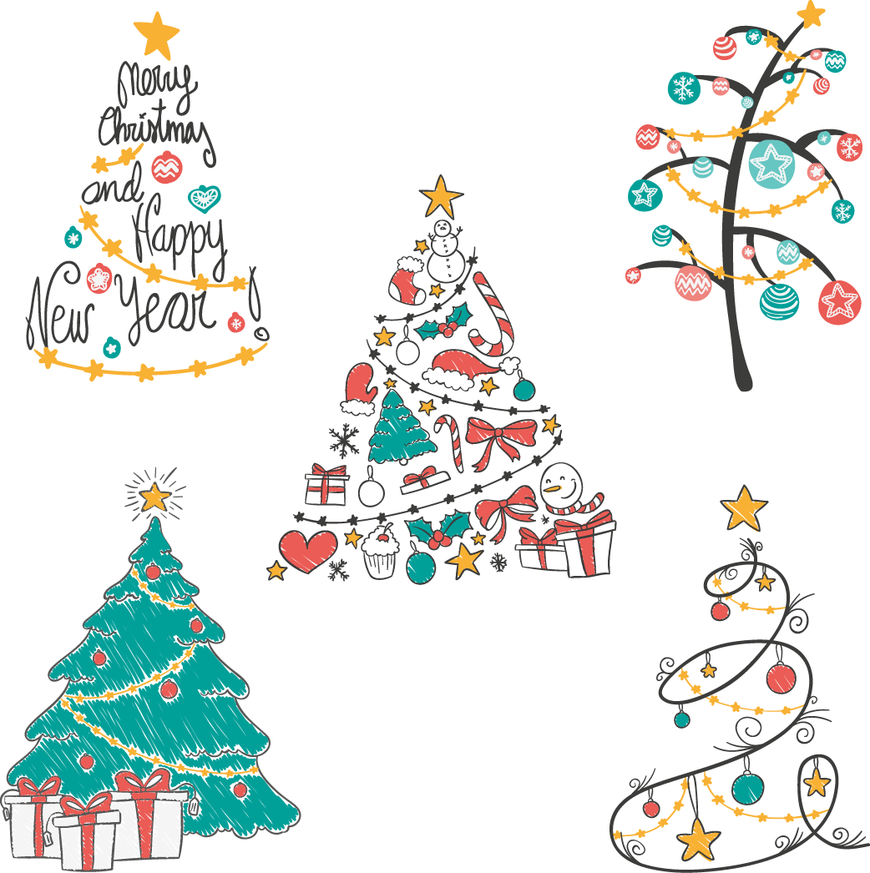
MERRY CHRISTMAS!
Amount:
_______________

To:
_______________
GIFT CERTIFICATE
A SPECIAL GIFT FOR YOU!
Valid throughout the holidays!
NO. 12345678
(You can add more details about your message in this space.)

A discount of $40 on purchasing gift item at our (Name & Location)
MERRY CHRISTMAS!
Amount:
_______________

To:
_______________
GIFT CERTIFICATE
A SPECIAL GIFT FOR YOU!
Valid throughout the holidays!
NO. 12345678
(You can add more details about your message in this space.)

A discount of $40 on purchasing gift item at our (Name & Location)
MERRY CHRISTMAS!
Amount:
_______________

To:
_______________
GIFT CERTIFICATE
A SPECIAL GIFT FOR YOU!
Valid throughout the holidays!
NO. 12345678
(You can add more details about your message in this space.)

A discount of $40 on purchasing gift item at our (Name & Location)

