

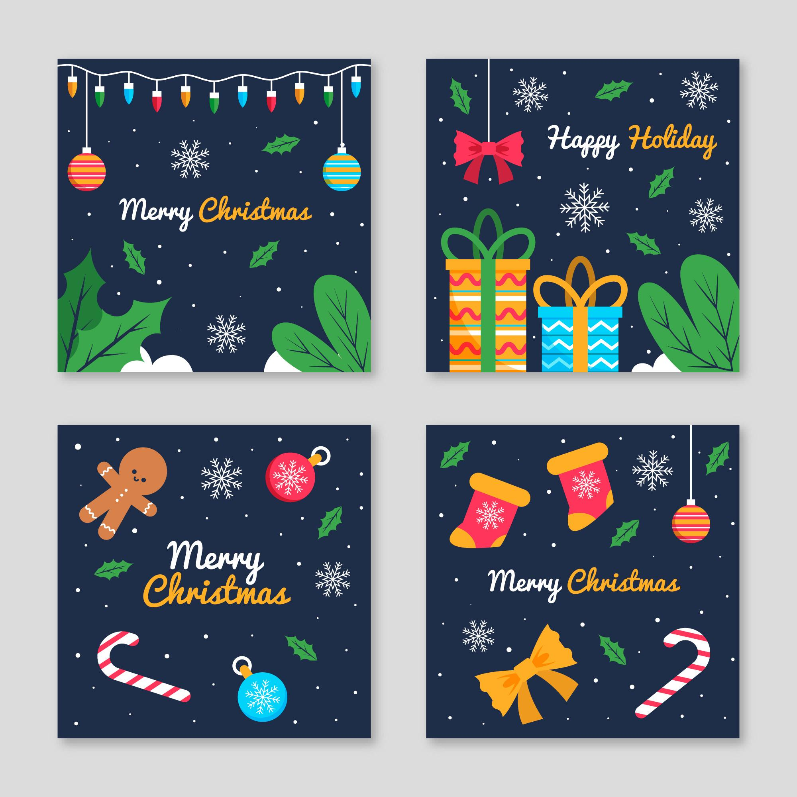
May you have to December to remember
Let the beauty of the season
Fill you with warmth and
Happiness!!
23rd December 20___
Lorem ipsum dolor sit a met Consectetur adipiscing elit Vivamus vitea luctus leo vitae Dignissim quam Sed placerat neque in ele entum euismod risus sed urna Purus, volute Pat quis varius id fragile non-urna.

Drinks & Music

Please bring a treat to share
592 Escalante Court, Oakland
rsvp’s 555 - 289696

