
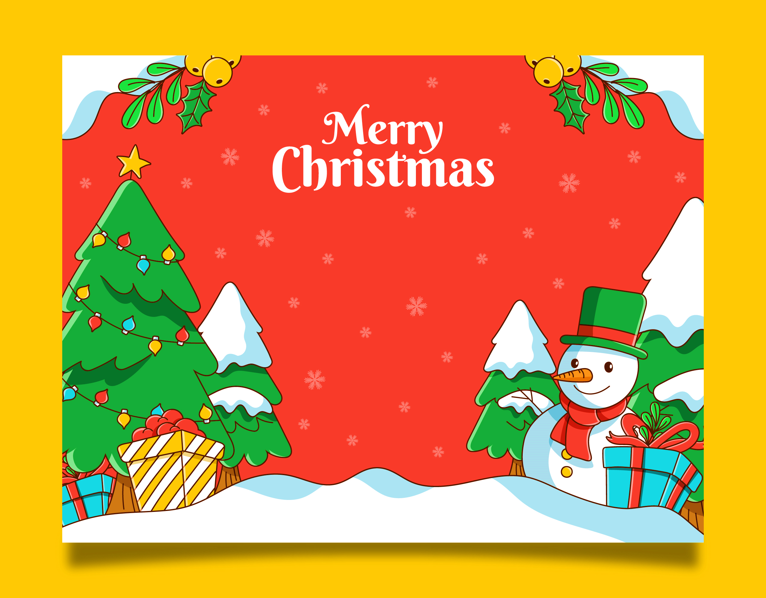
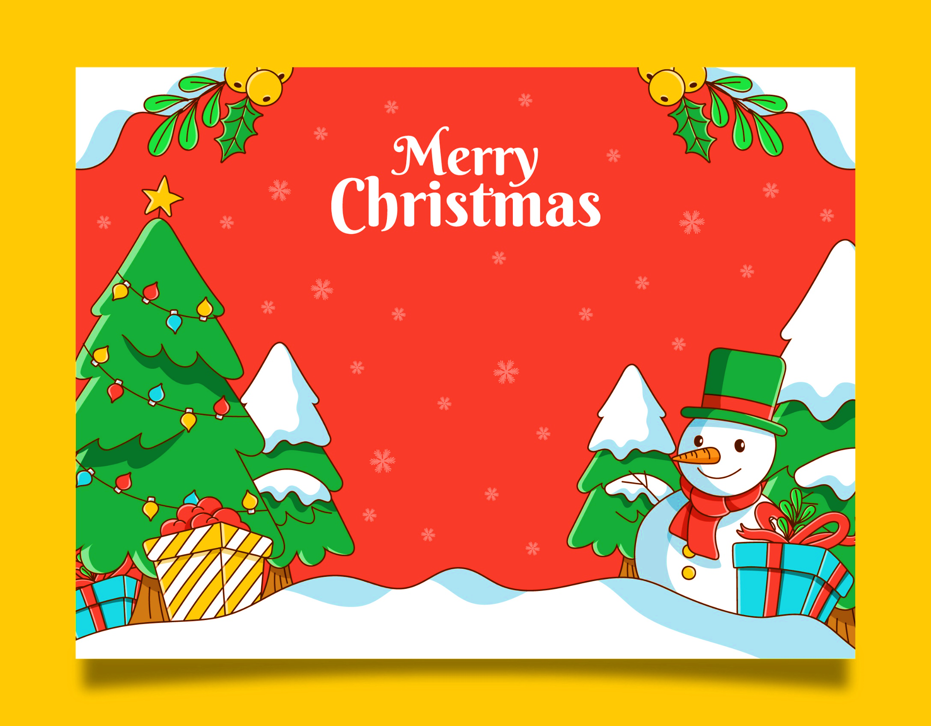
23rd December 20___
Lorem ipsum dolor sit a met Consectetur adipiscing elit Vivamus vitea luctus leo vitae Dignissim quam Sed placerat neque in ele entum euismod risus sed urna Purus, volute Pat quis varius id fragile non-urna.

Drinks & Music

Please bring a treat to share
592 Escalante Court, Oakland rsvp’s 555 - 289696

Peace on earth will come to stay
When we live Christmas every day
You’re invited to our
Christmas Party

